HOLY ARCHANGELS MICHAEL AND GABRIEL (NOVEMBER 8)
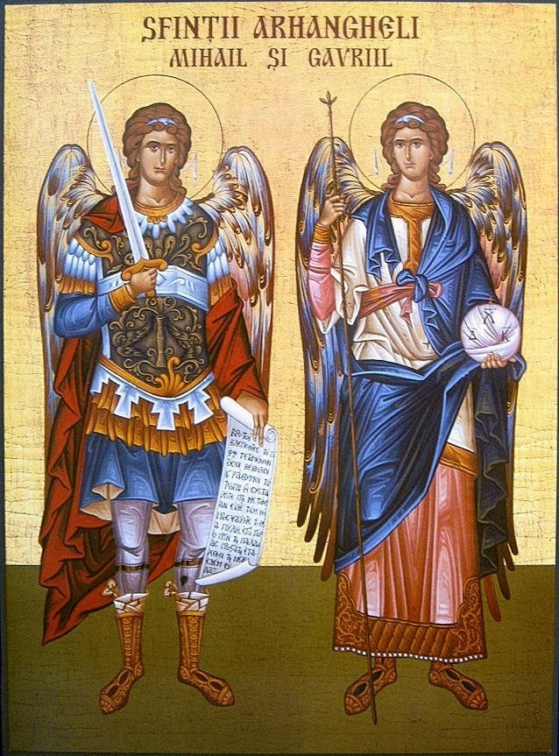
Holy Archangel Michael: is the leader of the guardian angels in heaven. He has the duty to keep the law of God and defeat the powers of the evil one. He is sent to protect us.
Representation in the icon: in his right hand he holds a cross and a sword with a ribbon to fight the evil one, and in his left hand he holds a green palm branch showing that he is the defender of the faith.
Holy Archangel Michael in the Bible: “And war broke out in heaven. Michael and his angels fought with the dragon; and the dragon and his angels fought, but they did not prevail, nor was a place found for them in heaven any longer” Revelation 12:7-8. This shows that Holy Archangel Michael will fight against evil and will win.
Holy Archangel Gabriel: is a spiritual power from God and the keeper of His mysteries. His mission is to announce the mysteries of God to the people.
Representation in the icon: in his right hand he holds a lantern with a lighted candle to guide us, and in his left hand he has a mirror of green jasper to show us the wisdom of God's mysteries.
Holy Archangel Gabriel in the Bible: “Now in the sixth month the angel Gabriel was sent by God to a city of Galilee named Nazareth, to a virgin betrothed to a man whose name was Joseph, of the house of David. The virgin’s name was Mary. And having come in, the angel said to her, «Rejoice, highly favored one, the Lord is with you; blessed are you among women!»” Luke 1:26-28. This shows us that he is the one who announced the birth of Our Savior Jesus (Annunciation).

- Fill in the blanks using the words below:
Holy Archangel Michael is a __ __ __ __ __ __ __ in Heaven. Holy Archangel Gabriel has the duty to __ __ __ __ __ __ God’s messages. God sends us a guardian __ __ __ __ __.
angel, guardian, announce

- Analyze the icons based on the knowledge you’ve gained. Identify the Archangels from the icon above:
Holy Archangel __ __ __ __ __ __ Holy Archangel __ __ __ __ __ __ __

- Memorize the following prayer:
“Praise Him, all His angels; praise Him, all His hosts. Let them praise the name of the Lord; for He spoke, and they came to be; He commanded, and they were created.” (Psalms)
- Color one of the icons below:
