FASTING – PREPARATION FOR THE FEAST
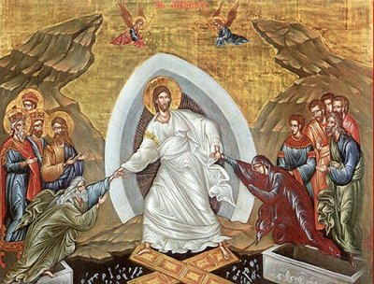
HOLY PASCHA represents the most important feast in the religious calendar and we, as Orthodox Christians, try to prepare for the Resurrection in several ways during the Great Lent. The Great Lent is the period when we are preparing for the Resurrection. It is actually the time when we try to become better people and follow the path of God. We are trying to improve the way we interact with God and with each other. We do this through prayer, confession, almsgiving, fasting and participation in the services of the Great Lent. This is a period of cleansing our body and spirit to be ready for the Resurrection. During this period we can even clean our house. When we prepare, we are worthy of God's forgiveness. This period lasts forty days and ends with the Holy Week followed by the Resurrection.
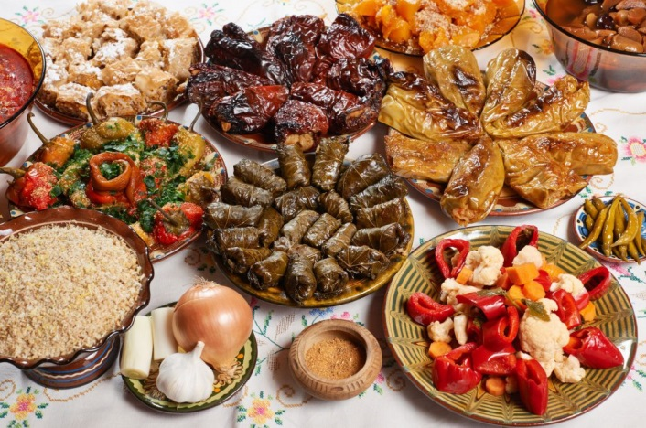
FASTING is one of the ways to cleanse our body. The Bible tells us that observing the fast can bring us many accomplishments. During the Great Lent, several foods are forbidden, such as: meat, cheese, eggs, oil, fish, milk, and wine. There are some exceptions, such as the Annunciation and Palm Sunday, when fish is allowed.

PRAYER: During the Great Lent we have many additional opportunities to get closer to God through prayer. We can do this during the special services of the Great Lent: the Liturgy of the pre-sanctified gifts, Great Compline and the services dedicated to the Mother of God. This way we have many opportunities to receive Holy Communion.
PRAYER THAT IS SAID DAILY DURING THE GREAT LENT:
O Lord and Master of my life! Take from me the spirit of sloth, faint-heartedness, lust of power, and idle talk. But give rather the spirit of chastity, humility, patience, and love to Thy servant. Yea, O Lord and King! Grant me to see my own errors and not to judge my brother; For Thou art blessed unto ages of ages. Amen. – Prayer of Saint Ephraim the Syrian

Activity:
Unscramble the words to discover how we can prepare during the Great Lent to celebrate the Resurrection:
A T F N S G I _ _ _ _ _ _ _
E O S G S O N D _ _ _ _ _ _ _ _
R A P R E Y _ _ _ _ _ _
A Y R H C T I _ _ _ _ _ _ _
T T S Y H I C A _ _ _ _ _ _ _ _
O N S E F N O S C I _ _ _ _ _ _ _ _ _ _

