Five Finger Prayer
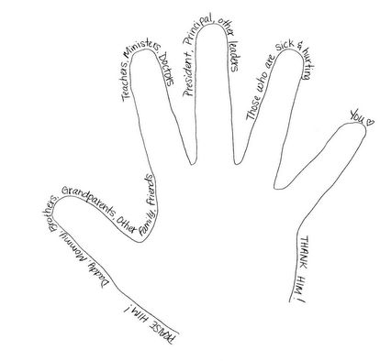
I first learned about this prayer years ago. I love that it is simple, sweet, and so effective! Truthfully, you really don’t have an excuse not to do it. Your hand is attached to your body and is with you wherever you go, whereas your Bible may not always be with you. I have a Bible app on my BlackBerry so I really don’t have an excuse! For any of you that try this, I hope you love it as much as I do!
- Your thumb is nearest to you. Begin your prayers by praying for those closest to you. They are the easiest to remember. To pray for our loved ones is a “sweet duty.”
- The next finger is the pointing finger. Pray for those who teach, instruct, and heal. This includes teachers, doctors, and ministers. They need support and wisdom in pointing others in the right direction. Keep them in your prayers.
- The next finger is the tallest finger, which reminds us of our leaders. Pray for the national leaders, leaders in business and industry, and administrators. These people shape our nation and guide public opinion. They need God’s guidance.
- The fourth finger is our ring finger. Surprising to many is the fact that this is our weakest finger, as any piano teacher will testify. It should remind us to pray for those who are weak, and in trouble or in pain. They need your prayers day and night.
- And lastly comes our little finger, the smallest finger of all, which is where we should place ourselves in relation to God and others. As the Bible says, “The least shall be the greatest among you.” Your pinkie should remind you to pray for yourself. By the time you have prayed for the other four groups, your own needs will be put into proper perspective. You will be able to pray for yourself more effectively.

