FINDING THE HOLY CROSS - SIGN OF THE HOLY CROSS

(September 14th)

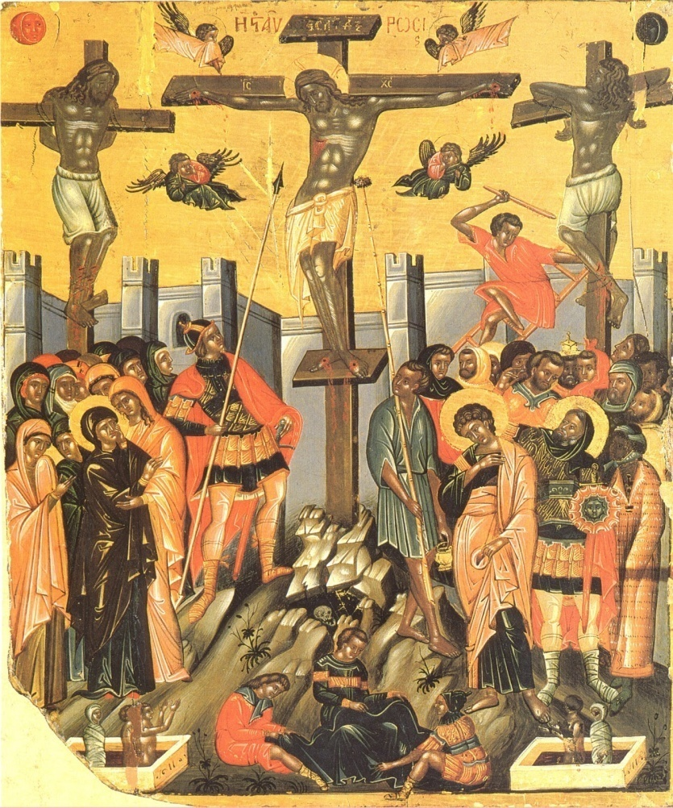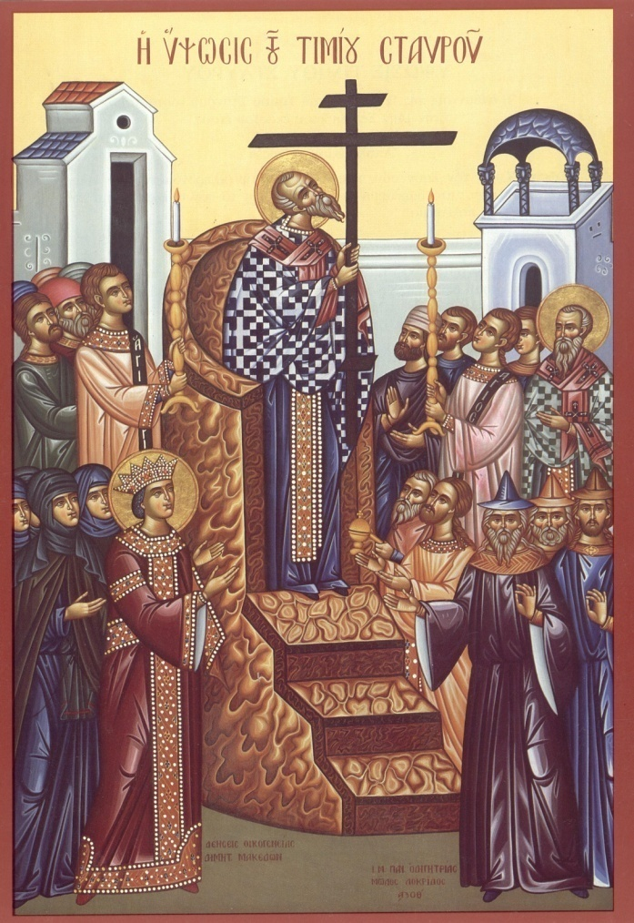

We, Christians, believe in God - the Father, the Son, and the Holy Spirit.
God is also known as Holy Trinity.
God loves us so much that He has sent His Son to become man, like us, to save us from the evil one (the devil). He came and taught us to love each other, and gave us power from the Holy Spirit to escape from the evil one’s deception.
He died on the Cross for us. But after three days, as a true God, Jesus resurrected.
Jesus died willingly on the Cross for us, and so He overcame the evil one. Seeing Jesus' love and sacrifice for us, many people began to love and follow His counsel.
The cross reminds us of the love of God for us.
The Holy Cross is the sign of Christians. Whenever we make the sign of the Holy Cross, we prove that we love God and offer ourselves to Him.
Through the Holy Cross, God gives us strength to do good and to keep us safe from the evil one.

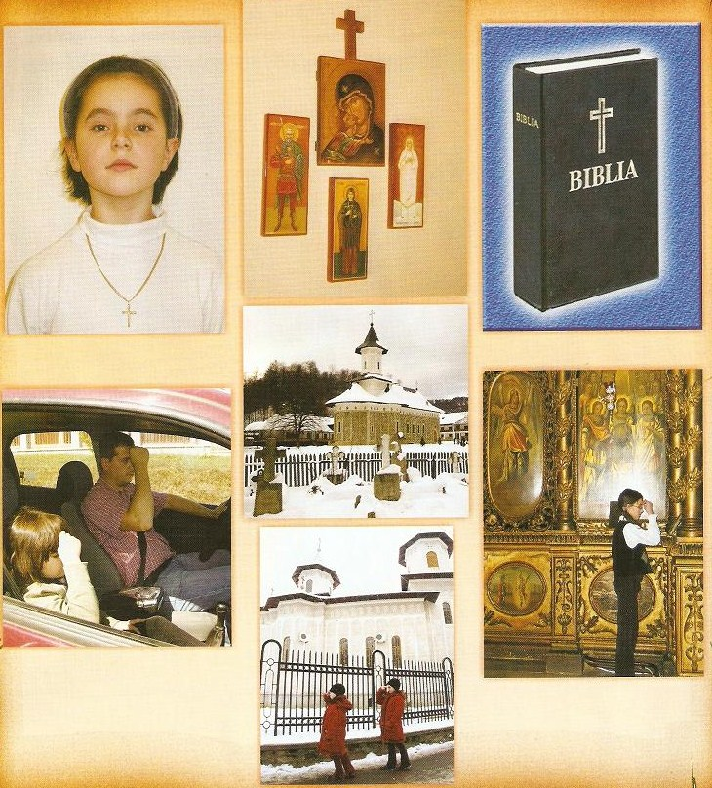
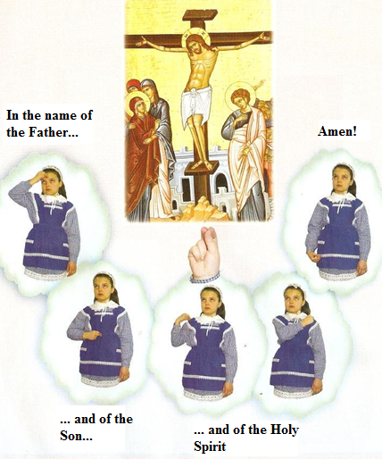

With the right hand we cross ourselves
Because we all know
That’s the hand we extend
When we meet with a friend.

We keep our fingers
Like we would hold a pen
Three united in a point,
Two folded in the palm.

And that’s how we touch our forehead
And below our heart,
Then across the shoulders
Starting from the right”.
Fr. C. Popescu

How to make the sign of the Holy Cross correctly:

We bring the tips of the first three fingers together (the thumb, index and middle ones), and bend the last two (the "ring" and little fingers) against the palm.

While saying:
“In the name of the Father, and of the Son, and of the Holy Spirit. Amen!”

1. You touch your forehead with your right hand while saying:
“In the name of the Father”

2. You bring your right hand and touch your tummy saying:
“and of the Son”

3. You touch your right shoulder, then your left while saying:
“and of the Holy Spirit”

4. While bringing down your right hand you say:
“Amen!”

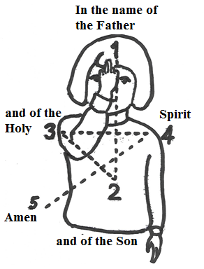

Connect the dots and you will learn how to make the Holy Cross correctly.

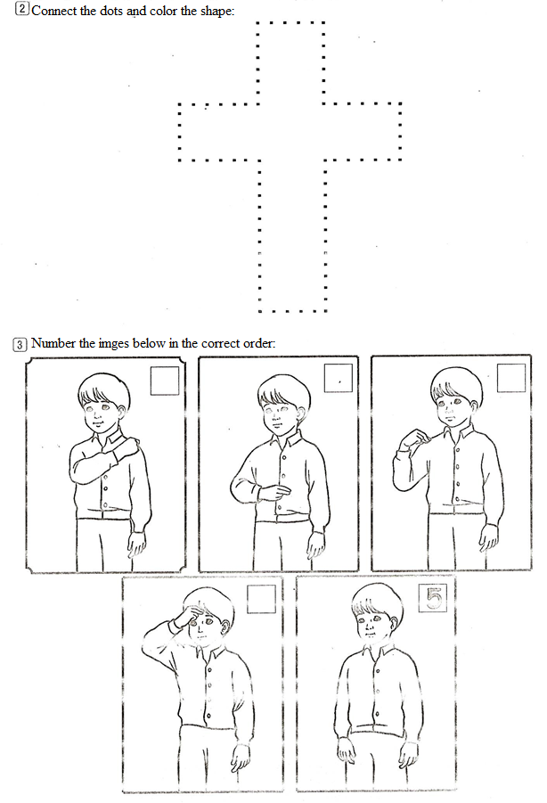
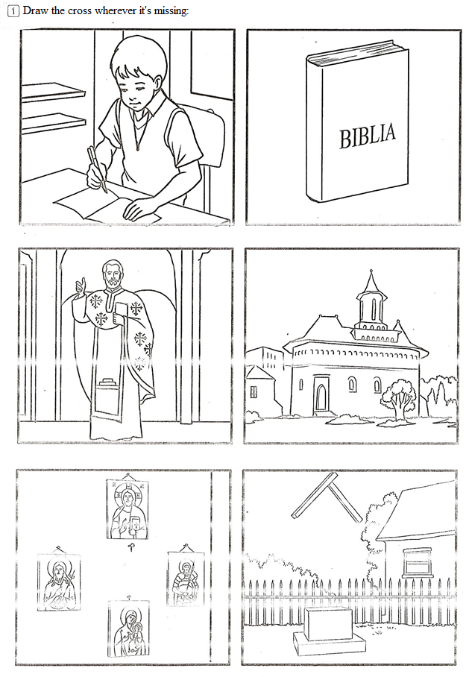
Do your best coloring the Holy Cross of the Savior:
