THE CHURCH – HOUSE OF GOD

The Holy Church is the house of God. Children go with their parents to the church. There the priest talks about God. How beautiful it is to be in the church! The Church is the Holy House of God where we meet and can be in dialogue with Him.
Recognize the House of God:
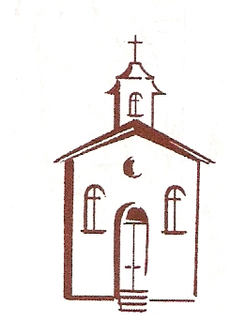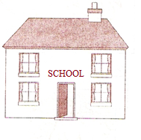

Let’s build a model of a Holy Church:
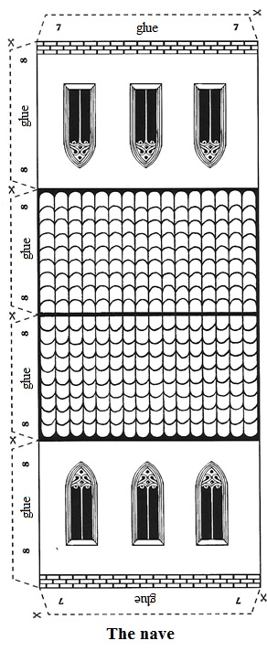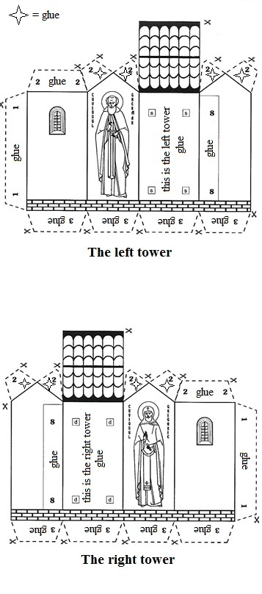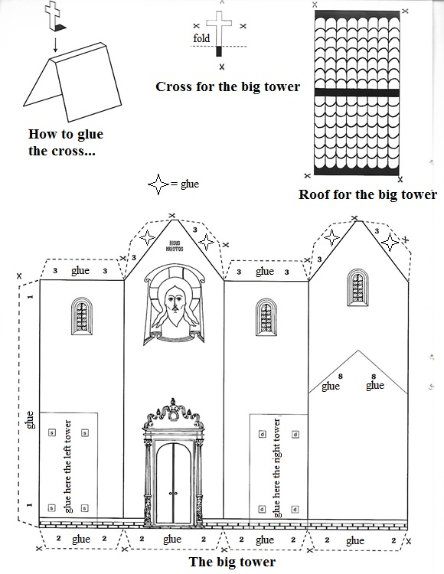

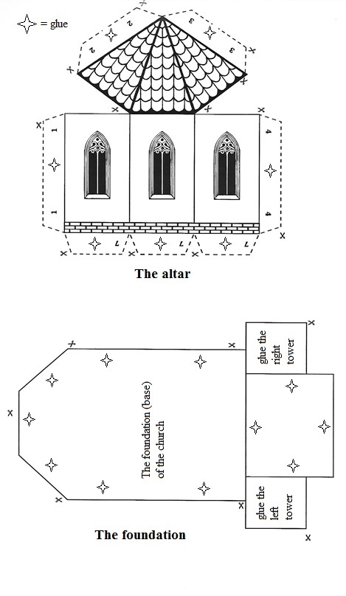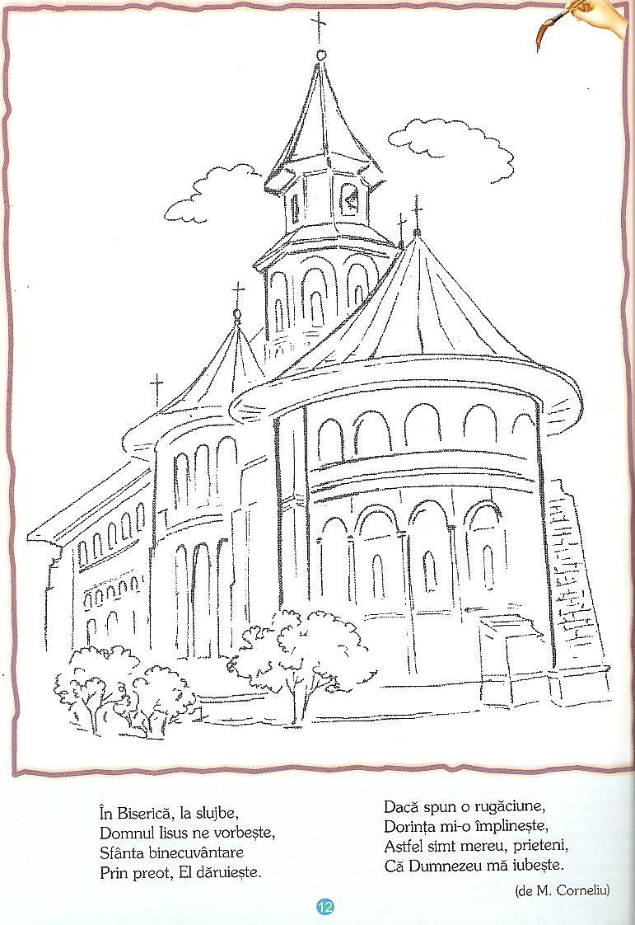
Color and then memorate the poem:

In the Church, during services,
Our Lord Jesus talks to us,
Holy blessing
Through the priest, He gives.
If I say a prayer,
My wish He fulfils
So I always feel, my friends,
That God loves me.

(by M. Corneliu) .

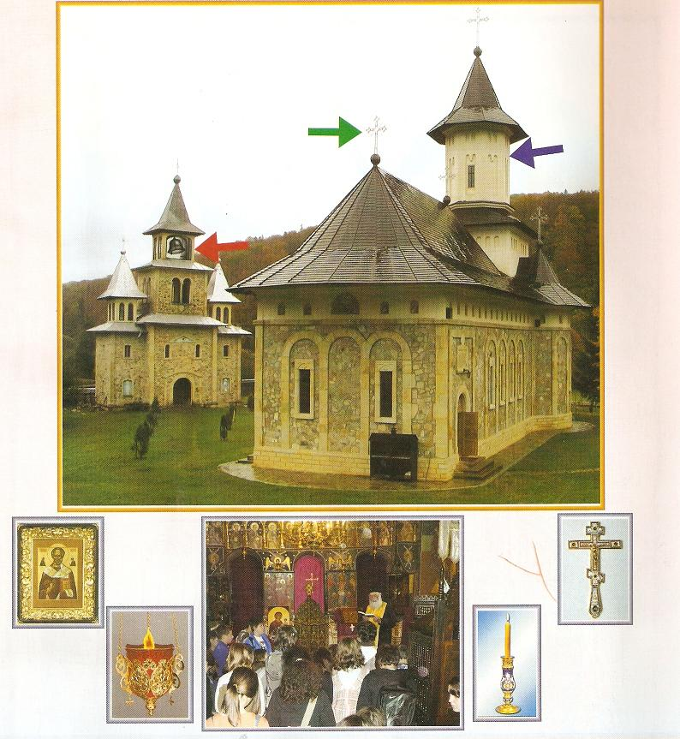
- Prior to the religion class you can organize a visit to the local church to observe its exterior/interior, meeting the parish priest and learning the proper way to act in the church.
- Have a dialog regarding differences between the church and the school (you can talk about form, exterior aspect, inside objects, activities happening inside, the leader of these activities).
- Talk to the children about the persons in the church (priest, chanter, believers) and the purpose of their presence in the church.
- Explain the children that the priest is the friend of Jesus Christ and their friend as well.
- Explain the children why do we need priests (e.g. they show us the path towards God).
- What do we see in the top image? What chirch element is indicated by the blue arrow? What about the red one? What about the green one?
- Who is the person facing forward in the image? What is he doing? What are the other people doing?
- What do you see in the other images? What are these objects used for?
- Why do we need to go to church? Are you going to church?
1. Antimins: a rectangular cloth consecrated by a bishop, upon which Jesus Christ is depicted being placed in the tomb. On the back of the Antimins there is a small pocket containing Holy Relics. The Antimins stays on the Altar Table. One is not allowed to celebrate the Liturgy without an Antimins.
2. Gospel: the book that contains parts of the Holy Gospels . It sits on the Altar Table because it contains the Word of God, the teachings of our Lord Jesus Christ.
3. Cross: sits on the Altar Table because it reminds us of Our Savior’s sacrifice and death on Golgotha.
4. Candlestick: reminds us of Jesus Christ, Who is "the Light of the World.". It holds one, two, three or seven candles.
5. Tabernacle: An elaborate wood or metal receptacle, usually in the form of that church, in which the Holy Gifts of the Eucharist are preserved for the communion of the sick or for those who cannot participate in the Divine Liturgy during the whole year.
6. Icons: they are everywhere in the church because that is where we meet God, Who in His boundless love for us became incarnate.
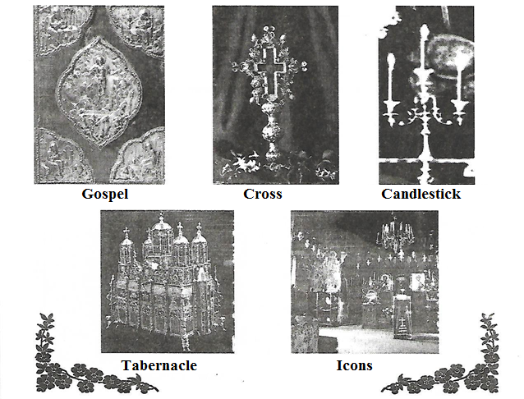
Try to draw the cult objects from the images above.

