THE HOLY APOSTLE ANDREW - APOSTLE OF THE ROMANIANS

(NOVEMBER 30)
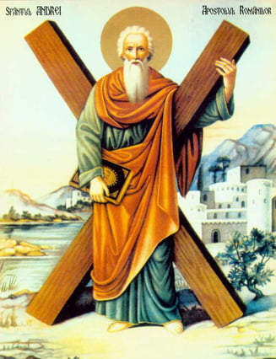

Read the following text and listen to the instructions given to you:
Holy Apostle Andrew and Jesus Christ in the Bible
“One of the two who heard John speak, and followed Him, was Andrew, Simon Peter’s brother. He first found his own brother Simon, and said to him, “We have found the Messiah” (which is translated, the Christ). And he brought him to Jesus. Now when Jesus looked at him, He said, “You are Simon the son of Jonah. You shall be called Cephas” (which is translated, A Stone).” John 1:40-42.
Let’s meet Holy Apostle Andrew:
- Saint Andrew was the first one called by Jesus. He and his brother, Simon-Peter, were fishermen. Christ said to them: “Follow Me, and I will make you become fishers of men.” Mark 1:17 (Jesus meant that he would teach them how to preach the Word of God).
- Saint Andrew was from Bethsaida, near the Sea of Galilee. He followed Jesus through the Holy Land and witnessed many of Jesus' miracles.
- After the Pentecost (Descent of the Holy Spirit), it was decided for Saint Andrew to go to the Eastern countries to preach the Word of God. He went along the coast of the Black Sea and the Danube River, in Scythia Minor (Dobrogea), Thrace, Macedonia, Greece and many other places, then returned to the city of Patra, in Byzantium.
- Saint Andrew was a good preacher and he helped many people to become Christians. He healed the sick through the power of the Holy Spirit. He established many churches and ordained many priests and bishops. The Patra’s prefect got angry at him because everyone wanted to listen to his sermons.
- He was crucified on an X-shaped cross and died a martyr. He is buried in the Church of the Holy Apostles. He is the patron saint and protector of Romania, as well as of many other countries (which is why we Romanians consider him the Apostle of Romanians).

Fill in the blanks using the given words:
1. Saint Andrew was the first one __ __ __ __ __ __.
2. Saint Andrew was from Bethsaida, near the Sea of __ __ __ __ __ __ __ __.
3. Saint Andrew went to the Eastern countries to __ __ __ __ __ __ __ __ __.
4. He healed the sick through the power of the __ __ __ __ __ __ __ __ __ __ __.
5. He is the patron saint and protector of the __ __ __ __ __ __ __ __.

Galilee Holy Spirit preach Romanians called

Memorize the following prayer:

Andrew, first-called of the Apostles and brother of the foremost disciple, entreat the Master of all to grant peace to the world and to our souls great mercy.
Troparion of St. Andrew (Tone 4).
Color Saint Andrew’s icon:
