SAINT JOHN THE BAPTIST
“Saint John, deliver from all needs those who run to you…” (from Saint John’s Akathist)
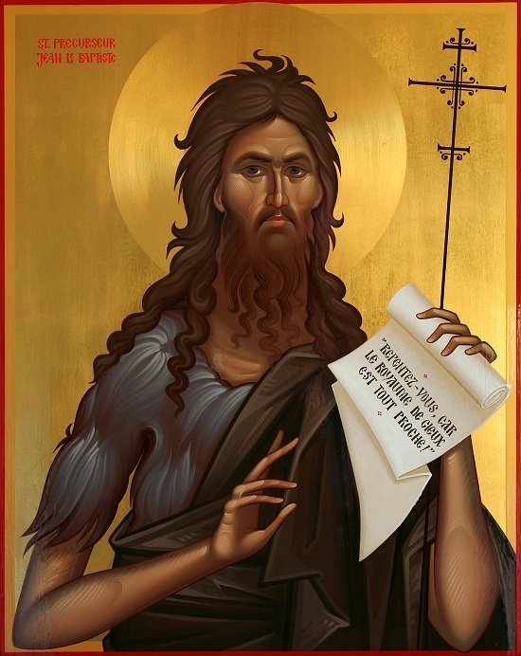
His parents, Zacharias and Elizabeth, were two God-fearing elderly people. For many years, they prayed to God with much faith to bless them with a child.
One day, Zacharias, who was a priest and served in the temple, received a message from Archangel Gabriel that God will give them a child, and his name will be John.
The archangel also told him that the child will be filled with the Holy Spirit and will preach the coming of the promised Messiah, Jesus Christ, as well as the way mankind will need to prepare to receive Him.
“And Zacharias said to the angel, “How shall I know this? For I am an old man, and my wife is well advanced in years.” And the angel answered and said to him, “I am Gabriel, who stands in the presence of God, and was sent to speak to you and bring you these glad tidings. But behold, you will be mute and not able to speak until the day these things take place, because you did not believe my words which will be fulfilled in their own time.” (Luke 1:18-20)
A few months later, Elizabeth received a visit from her cousin, the Virgin Mary, who had been chosen by God to give birth to His son. As soon as she entered the house of Zacharias, Elizabeth felt the baby leap into her womb, thus confessing to the Messiah before he was born.
“Now Elizabeth’s full time came for her to be delivered, and she brought forth a son.” (Luke 1:57)
“When her neighbors and relatives heard how the Lord had shown great mercy to her, they rejoiced with her.” (Luke 1:58)
And on the eighth day they came to call his name, and they all called him Zacharias, after the name of his father. But Elizabeth said: No; he shall be called John.
Those present said to her: There is no one among your relatives who is called by this name.
“So they made signs to his father – what he would have him called. And he asked for a writing tablet, and wrote, saying, “His name is John.” So they all marveled. Immediately his mouth was opened and his tongue loosed, and he spoke, praising God.” (Luke 1:62-64)
Six months after John's birth, news broke that Herod had sent his soldiers to kill all the infants less than two years old, so Elizabeth, who was now a widow after her husband Zacharias was murdered, hid with her son in a hollow of a mountain.
But not long after, she died and John was left alone in the wilderness.
The baby was taken under the protective wing of an angel sent by God, who took care of him, while preparing him for the mission he was to fulfill.
- Reconstitute the life of Saint John the Baptist by looking at the images below:
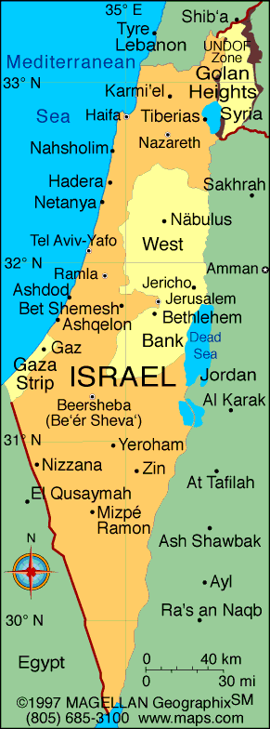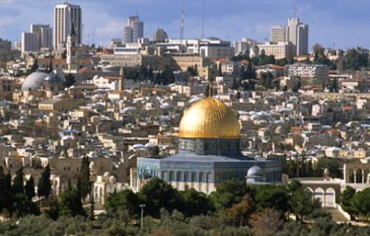
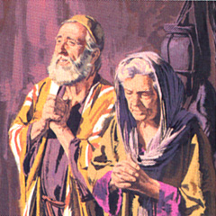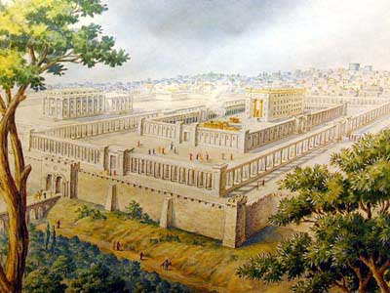
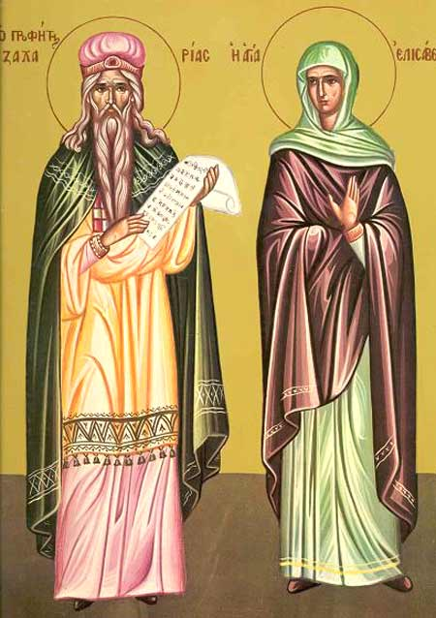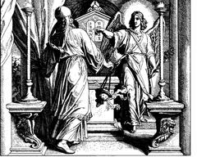
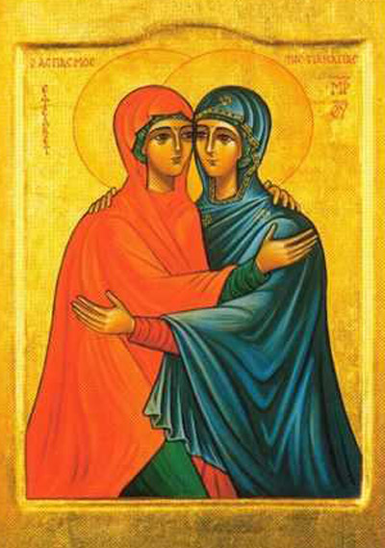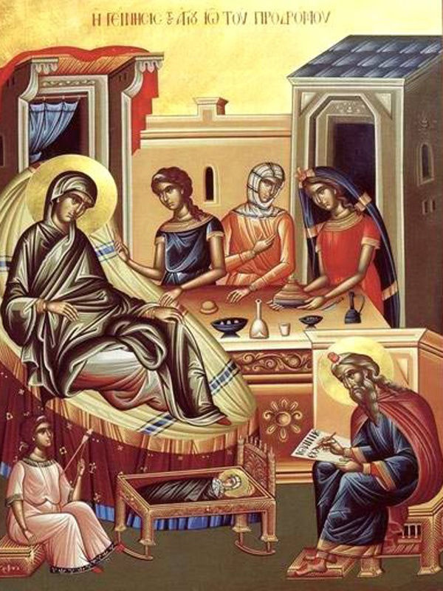
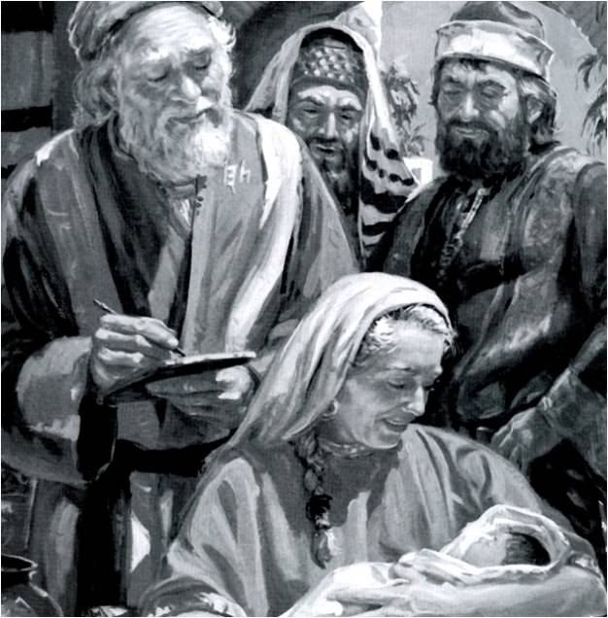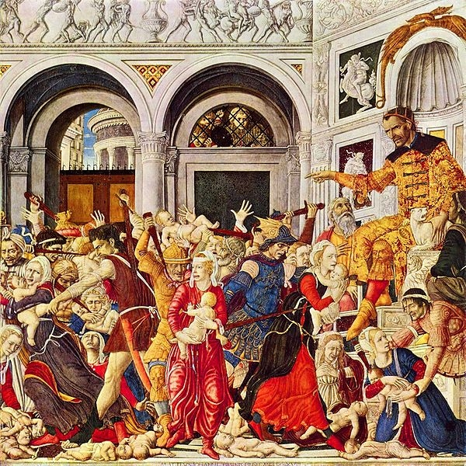
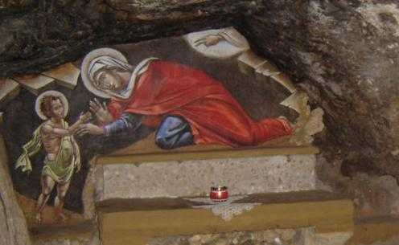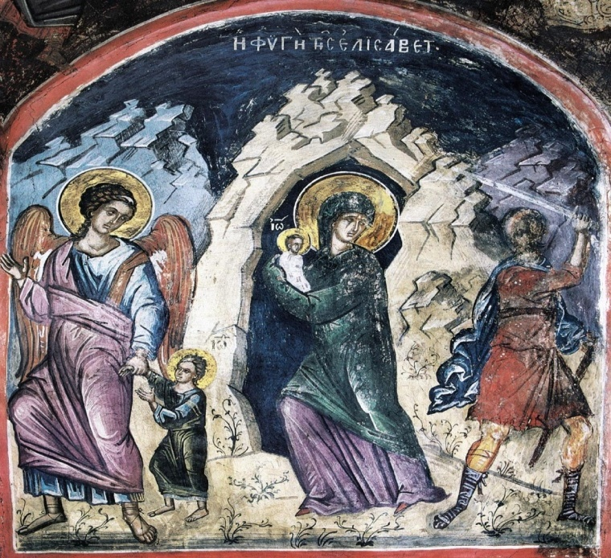

- Color the image where Saint John teaches the people about the coming of the Messiah: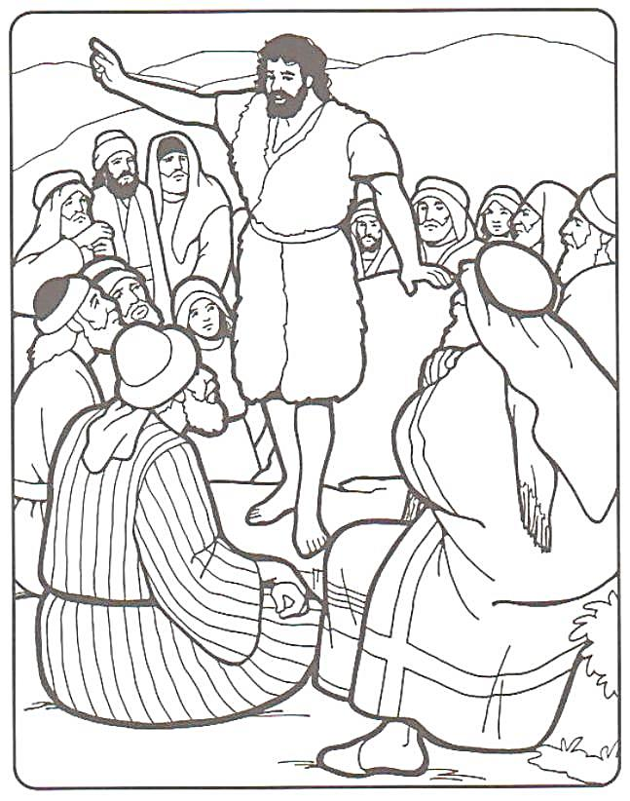
- Color the praying hands:


