ABOUT HOLINESS AND SAINTS, PEOPLE PLEASING TO GOD
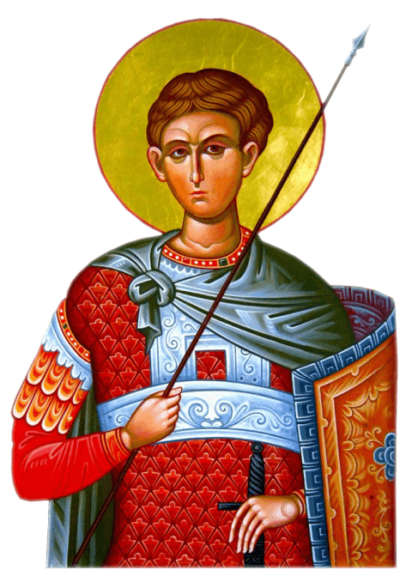
- Biography – Holy Great Martyr Demetrius:

- Born in Thessalonica (Greece) from faithful parents, during the pagan emperors Diocletian and Maximian;
- At a young age, after his father died, he was appointed the proconsul of the Thessalonica district;
- He was remarkable during wars, being very much appreciated by the Emperor;
- Following a victory that Maximian obtained, the Emperor ordered the inhabitants of Thessalonica to worship the Roman gods; St. Demetrius refused to do that.

- Martyrdom
- locked in prison
- beaten
- ran through with spears
- through the prayers of St. Demetrius, a young Christian named Nestor defeats the fierce Lyaeos, a pagan who was killing Christians by throwing them over upturned spears.

- End of life:
- After the Emperor heard that St. Demetrius has blessed young Nestor to fight with Lyaeos, he ordered for Nestor to be beheaded, and St. Demetrius to be ran through with spears.
- dies on October 26th, 299 A.D.

Write down brief notes on St. Demetrius:
- place of birth:
- parents:
- occupation:

Write down the torments Saint Demetrius was put through:

Write down notes on Saint Demetrius’ end of life:

Arrange the words in a sentence to discover one of this lesson’s teachings, using the colors and shapes:
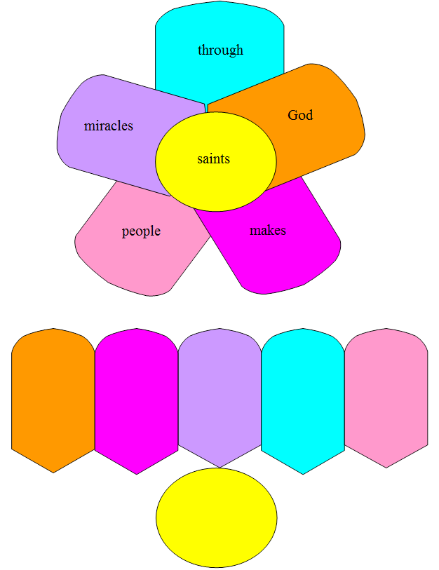
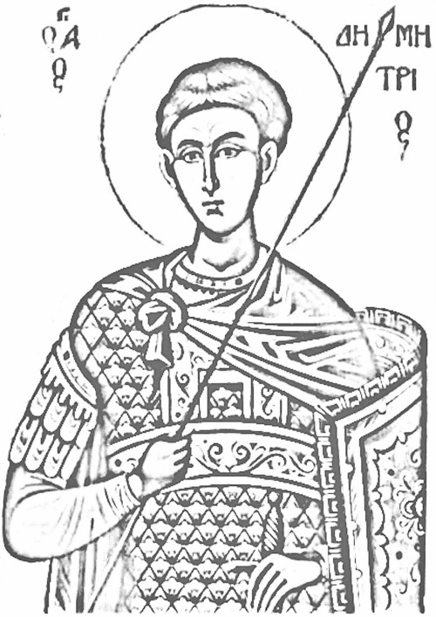
Color the image based on the icon of the Holy Great Martyr Demetrius.

