BEHEADING OF SAINT JOHN THE BAPTIST

(AUGUST 29)

The saint was wearing clothes made from camel’s hair, fastened with a girdle of raw leather, and he lived eating only locusts and wild honey.
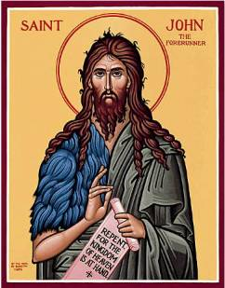
Once he reached the age of thirty, Saint John began to preach to people about the coming of the Messiah. His sermon, full of the power of the Holy Spirit, attracted many people from all over the country.
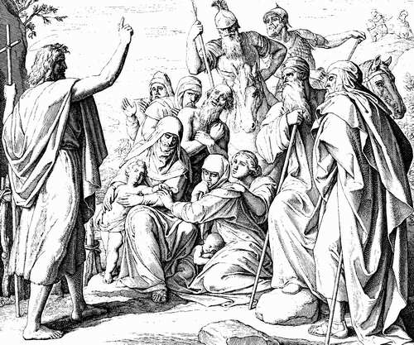
He told them that although they are part of God's chosen people; they are not prepared to receive His Son. Therefore, he urged them all to repent, to do good deeds, to be honest, compassionate and moral.
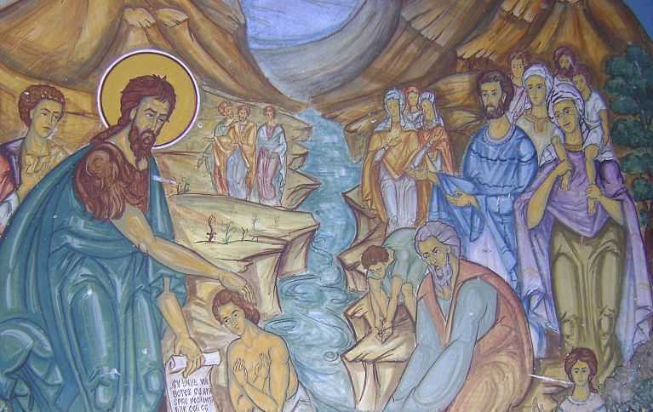
When asked by the people and the Pharisees if he is the Christ, John answered them saying that when He comes, the Messiah will baptize with the Holy Spirit and fire, not water, as he did. He also told them that Christ is far superior to him, and he was not even worthy to untie the straps of His sandals.
As a reward for the sanctity of his life, God granted him the great honor of baptizing His Son at the Jordan River.

Only a man of great worthiness, like himself, could have received from God the permission to baptize Christ, the Savior of the world. The Baptism of the Lord is celebrated by the Orthodox Church every year on January 6th and this feast is also called "Epiphany" or "Theophany" (during the Baptism of the Lord, God the Holy Spirit appeared to the world like a dove, and a voice came from heaven saying "This is My beloved Son, in whom I am well pleased, listen to Him."). The Feast of Saint John the Baptist is celebrated on January 7th.

Excercises:
Arrange cards with images from the life of St. John the Baptist in chronological order, then make a poster with them and specify briefly what each one means.
Memorize the following prayer:
"Saint John the Baptist, pray to God for us!"

