THE GUARDIAN ANGEL – THE “MY ANGEL” PRAYER
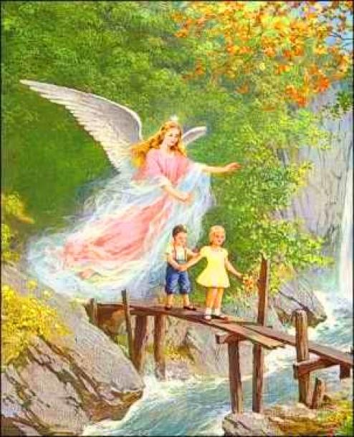
- Memorize the “My Angel” prayer:
Angel, angel, my dear angel,
Bestowed upon me by God,
Always be with me
And teach me to do well.
I am little, you make me big
I am weak, you make me strong.
Go with me everywhere
And keep me safe from evil.
God, let your angels
Be my guardians
In the day and in the night
Until the hour of death. Amen!

- Look at the picture above and listen to the story that follows, then explain how our guardian angel is helping us.
There was a village with a river running through the middle; the school was on the other side of the river and the bridge over it was not very good. Many planks were missing from place to place, and the bridge was always swaying, more and more likely to fall. Everyone had to cross that bridge one by one, because it was so narrow. When the children left home, their mothers would tell them to be careful when crossing the bridge, not to look left or right, otherwise they would fall, but to look ahead, and that their angel will watch over them and they will get to school safely.
One day, Johnny and, Irina, two good, obedient and very faithful children, left home for school. Halfway up the bridge they saw a butterfly flying and started to look at it, carried away by its beauty. One more step and they were about to fall into the water... But suddenly someone invisible appeared next to them and lifted their legs onto the bridge, allowing them to move forward and cross the river safely.
Do you know who protected Johnny and Irina?
- The guardian angel.

- Read the poem:
The child and the angels
„Where are you staying, little angels? How could I, oh, lovely ones,
And what are you doing, lovely ones? Be an angel, just like you?
Near our Father we stay, Just be good and obedient
We sing and worship Him. And you could be our brother too."

- Guess the answer to the riddle:
It is sent by God,
It is your guardian.
It is always close to you
Both in the day and in the middle of the night;
It will always accompany you
Both in good and difficult times!
- Create a paper angel according to the model below:
