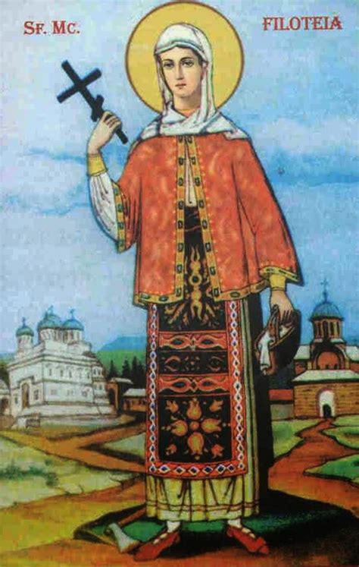
HOLY MARTYR FILOFTEIA – THE GIRL WHO LOVED ALL PEOPLE
The Holy Martyr Filofteia was born in the city of Târnovo to Christian parents of Bulgarian descent.
Her mother died unexpectedly, but the little girl lived as her mother taught her: loving God and helping the poor, she lived in fasting, prayer and good deeds.
One day, while she was in the church, she heard the word of God: "Blessed are the merciful, for they shall obtain mercy". These words penetrated her soul so much, that from then on she could not pass by a poor person without giving alms.
Once, her father spied on the child while she was bringing him food to the work field. When he saw her happily feeding the poor from his meal, he got angry and threw his ax at her. The little girl died instantly, giving her soul into the hands of God at the age of 12.
A light appeared around her body, a sign from God that due to her pure life she became holy in the Kingdom of God.
Her holy relics are now at the Curtea de Argeş Monastery.
Orthodox Christians honor Saint Filofteia every year on December 7.

Divided into four groups, solve the following exercises:

Group #1: write what the following pictures represent: (Holy Martyr Filofteia, Saint Filofteia’s Holy relics, Curtea de Argeş Monastery).
- …………………………..……………………………….
- 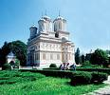………………………………...……………..
- 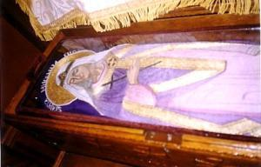…………………….…….……………..

- What are “Holy Relics”? ______________________________ _____________________________________________
Group #2: Fill in the blanks (use the words in parenthesis)
Saint Filofteia was a young _____________________________ girl who loved _______________________ and all ____________________ people. Being at the Church, she heard the word of God: Blessed are the _________________________ for they shall obtain mercy!”
(faithful, God, poor, merciful)

What does it mean to be merciful?
____________________________________________________________________________________________

Group #3: Underline the correct answer:
    - Filofteia loved:
- Children’s games
- Fasting and prayer
- Expensive and beautiful clothes
    - Her stepmother, seeing her works of mercy:
- Praised her
- Helped her to do more good
- Scolded her and complained to her father
    - When he saw that the young girl was giving part of his food to the poor, her father:
- Told her to prepare another package for the poor
- Praised her
- Got angry and hit her hard

What does „martyr” mean?

Group #4: Connect the statements that match:
Feeding the hungry
“For I was hungry and you gave Me food,

Clothing the naked
I was thirsty and you gave Me drink,

I was a stranger and you took Me in,
Caring for the sick

I was naked and you clothed Me,
Giving shelter to strangers

I was sick and you visited Me,

Giving drinks to the thirsty
I was in prison and you came to Me.”

What other Saint do you know of, who did acts of mercy like Saint Filofteia did?
What is the difference between a martyr Saint and a pious Saint?
What did we learn from Saint Martyr Filofteia?

