MOTHER OF GOD – PROTECTOR OF CHILDREN
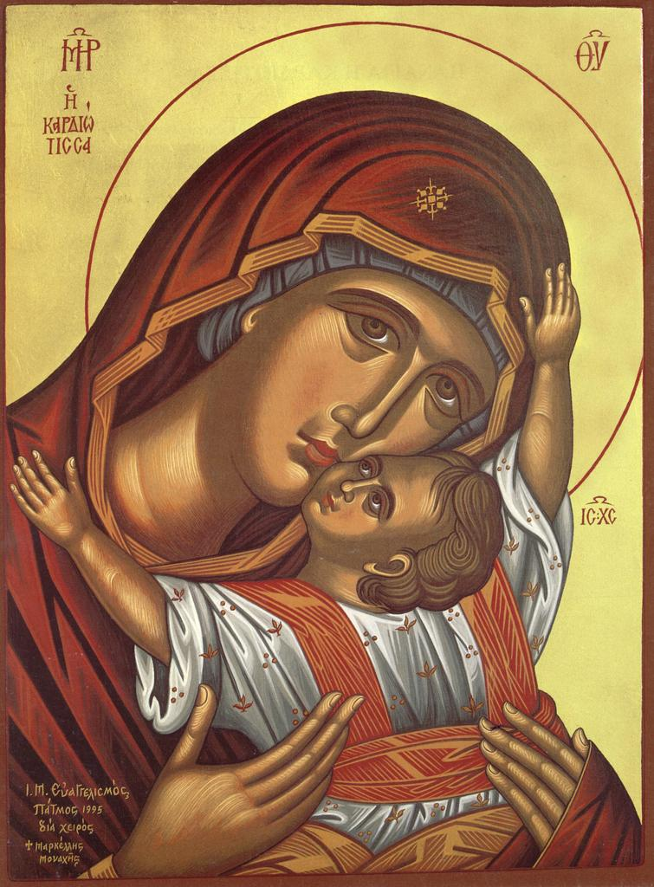
Listen to the following story:

Mother of God protects the good and faithful children
„There was once a good child who got lost from his parents. But God took care of him and helped him cross paths with a rich man. The rich man took the lost child with him to his house, which was next to a church. Near this house of the Lord there was a large cross, painted with the image of the Mother of God holding baby Jesus in her arms. The lost child often looked at Jesus. He thought that the child painted on the Holy Cross was alive. So, whenever he received bread, he broke it in half, walked to the Holy Cross, and offered a piece to Jesus saying:
- Here, little one, eat some. I know you must be hungry!
And, God, what a miracle! Baby Jesus stretched His hand and received the piece of bread from the merciful child. However, after a while, the rich man started to notice what the lost child was doing. He got angry and threw him out of the house saying:
- Go now to the little one, so He will give you food, I won’t give you anymore.
The merciful child left the rich man’s house. He went to the church, sat under the Holy Cross crying, and said to Jesus:
- Little one, I am very hungry... I can barely stand... If you can, give me something to eat! You know, I gave You food when I had it.
Suddenly, the Mother of God, taking pity on the child, descended from the cross. She took a large loaf of bread from under Her arm, and gave it to the boy saying:
- Here, my dear!... he who gives, gives to himself. You gave to Jesus, my Son. Now I return your gift, so you’ll have something to eat for a long time.”
- To understand the moral of this story, ask children the following questions:

„What qualities had the child protected by the Mother of God?”

„Whom did the child ask for help after he was sent away from his home?”

„Did the Mother of God help him? Why?”

„What can we learn from this story?”

- Recognize the icons representing the Mother of God.

- The teacher asks the following questions:
- Where did you see icons with the Mother of God?
In the church, in the classroom, and at home on the wall.
- Why do you think your parents have icons of the Mother of God?

Explanation: Having the Mother of God in our hearts and in the icons, we are thinking more easily about her and asking her for help whenever we need it. Mother of God never forgets to help the good and faithful people who ask for her help.

Observation:
The teacher gives each child an icon with the Mother of God, advising them to kneel and pray to the Mother of God whenever they are upset or they need help. The Mother of God will help and protect them if they pray faithfully.

- Read about the following miracle of the Mother of God:
„ Almost 500 years ago, an earthquake occurred on the island of Crete (Greece). Many buildings were then demolished. In the center of the city, where the greatest damage happened, there was a shoe workshop. The people who worked there were very faithful. On the wall of the workshop there was a painted icon of the Blessed Mother of God. The shoemakers often burned candles and incense in front of this icon, piously venerating it, especially before and after doing the work. Overnight, two children (apprentices) remained to guard the workshop that was locked by the shoemaker from the outside. On the night of the earthquake, the shoemaker ran to the workshop to open the door and free the children. Seeing that the whole workshop was destroyed, he thought that the children were obviously killed underneath the rubble. As he began to search for their bodies, he suddenly heard voices near the only remaining wall. He quickly removed the stones around and found the children alive and unharmed. Surprised, between joyful tears, the shoemaker asked them how did they escape alive. The children answered: “When we heard the earthquake's rumbling, we began to cry before the Holy Icon and prayed to the Blessed Mother of God for help. While praying, we saw that a veil came out of the icon and covered us. Afterwards, as soon as the stones and wood fell on that cover, they remained there, not hurting us. The Mother of God, looking exactly like she was painted in the icon, told us not to be afraid. She stayed with us until the moment you found us.”

Another way to show the Mother of God that we honor her is to follow her example: to try to be kind, obedient, faithful and more than everything: to pray to the Mother of God.

PRAYER TO THE MOTHER OF GOD
"Ever-Virgin Mother
Who shine in Heaven
Brighter than all the saints
And armies of angels."

- Sing together with the teacher: ”Most Holy Birthgiver of God, have mercy on us.”

Color the following images with the Mother of God:
