THE 40 HOLY MARTYRS – LOVE OF GOD (MARCH 9)
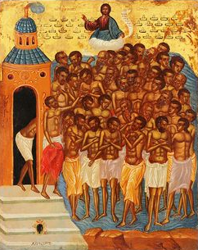
Martyrs (from Greek: μαρτυρος – witness) are those who gave their life under extreme conditions while confessing their faith in Jesus Christ.
Persecution: unjustly and persistently chasing someone, with the intent of causing harm or inconvenience;
Oppression: (limited meaning) insistently repeated injustice; persecution.
Starting from the 4th century, Christians were persecuted. The harshest anti-Christian persecution was during the time of Emperor Diocletian (284-305) who decreed the demolition of Christian churches, the banning of Christian gatherings and the burning of holy books, and then the arrest of Christian clerics and the killing of those who refused to renounce the Christian faith.
At a time when the persecutions had largely ceased, the pagan emperor Licinius did not accept faith in Christ. Learning that in Armenia, under the command of the governor Agricola, there were Christian soldiers, he ordered their return from their faith, especially since among them there were three, Cyrion, Candidus and Domnus, very skilled in the study of the Scriptures. Scholarly Christians were considered among the most dangerous, because they could bring solid arguments and enlighten people's minds to the true faith, moving them away from pagan, idolatrous practices.
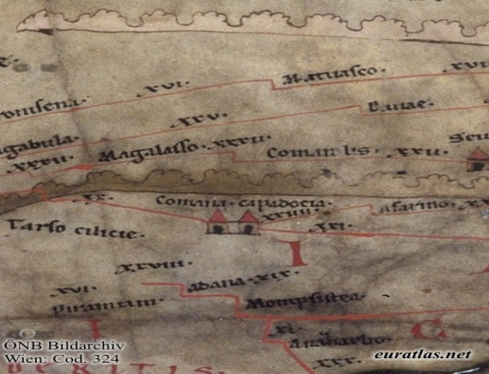
Gathering all the Christian soldiers, Agricola forced them to worship idols, then imprisoned them for 8 days, beating them with stones and enticing them with gifts. The 40 martyrs stayed up all night singing psalms. Through divine signs they were strengthened in the right faith, at dawn God himself appeared to them and strengthened them.
Coming to Sebaste, the renowned judge Licius again ordered them to sacrifice to the gods. With the same steadfast faith, the Christian soldiers resisted. Seeing that the forty did not want to obey them, the rulers decided to stone them, but the stones missed the saints and returned to strike those who had thrown them. One stone thrown by Licius hit Agricola in the face, smashing his teeth.
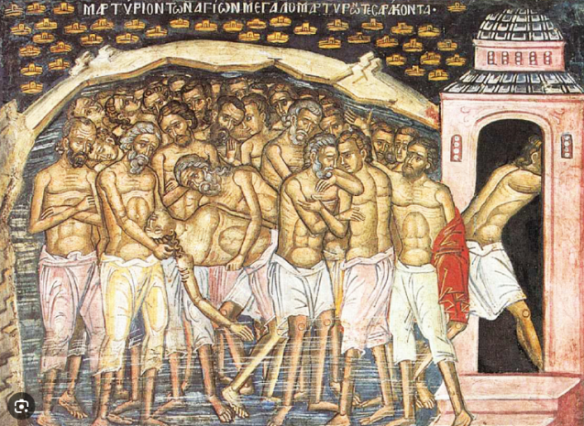
Enraged, the rulers ordered that the soldiers be stripped and forced into a lake, which was almost frozen, and they placed guards on the banks so that no one would run away. All night, the Christian soldiers sang psalms and prayed together, keeping each other warm. A soldier, no longer able to endure the cold, accepted to bring the idol sacrifice that was required of him: but, coming out of the frozen lake and entering the warm bath, specifically prepared, died immediately.
That night great miracles happened: the water of the lake warmed, the ice melted and 40 shining crowns descended on the martyrs. Seeing this, the guard Aglaius confessed in a loud voice: "I too am a Christian". Then he jumped into the frozen water, sharing in the martyrs’ passions and completing the group of forty martyrs, replacing the one who had denied Christ.
And when it was day, seeing with amazement that the soldiers were still alive, the rulers ordered their legs to be broken, and so they gave their souls to the Lord, taking the crown of martyrdom.
And the Lord, the One who guards all the bones of His beloved, did not let a single particle of them perish in the water, but kept them all whole. After three days, the saints appeared to the blessed Peter, the bishop of that city, saying to him: "Come at night and take us out of the river!" And he, taking his clergy and other pious men, went to the bank of the river, the night being very dark. And suddenly the bones of the saints shone in the water like stars; and wherever the smallest particle was, that place shone like a light. So, the bishop gathered all the bones of the saints from the water, down to one, and put them in a place of honor.

Color the saints according to the model. Then cut out and glue together the saints that look alike:
