
SAINT NICHOLAS – FRIEND OF CHILDREN (DECEMBER 6)

Read the story:
Long time ago, in a remote village, lived a family of faithful people and they had a son named Nicholas. He was a good kid, he loved school, he listened to his parents and he was doing only good deeds.
But time went by and he grew up and became a priest. Because he loved people he gave all his wealth to the needy.
Finding out that a poor man living in his city had three girls to marry, he took a bag of gold coins and, when the night fell, he went to the poor man’s house. Gold coins were money that was valuable in those times. St. Nicholas looked around and when no one saw him, he threw the bag with gold coins through the open window of the poor man’s house. Great was the poor man's joy when he found the money left by St. Nicholas. With this money he bought everything he needed to be able to marry his first daughter. St. Nicholas helped this way every one of the three girls.
St. Nicholas did not boast about his actions because he did them out of love for people. He loved people, especially the poor, but he loved children the most. Since those times it became a custom that every year, on December 6th, good and obedient children receive gifts. But not all children are good, so St. Nicholas brings them a little rod. He gently scolds them and tells them that God expects them to become better and more obedient.”

Solve the puzzle:

Since all children are thinking about gifts when talking about Santa Nicholas, ask them to write what they would like to receive this year:

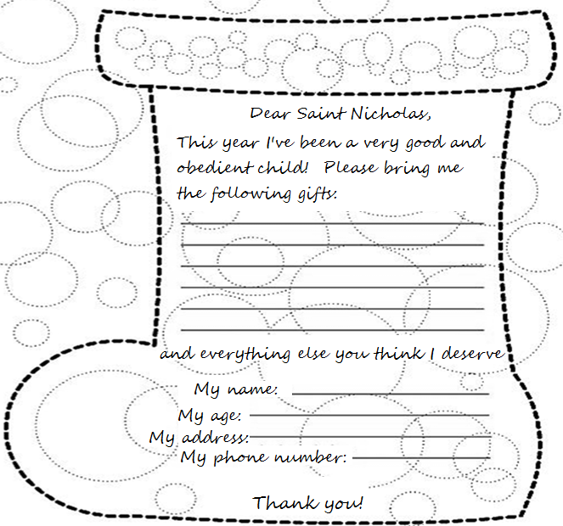

Color the drawing below:


Saint Nicholas – making a stocking

To begin with, we will print on the red paper the template for the boot, and on the white paper the one for the fur decoration. After this step, we will cut the two parts then apply the white part on the place marked on the template. Then we will cut the stocking on the continuous line and fold on the dotted line.

To make the stocking more beautiful and attractive, cut out your favorite winter decorations and apply them on the stocking. Fold, combine and glue the parts together. SUCCESS!
