SAINT STYLIANOS, PROTECTOR OF CHILDREN
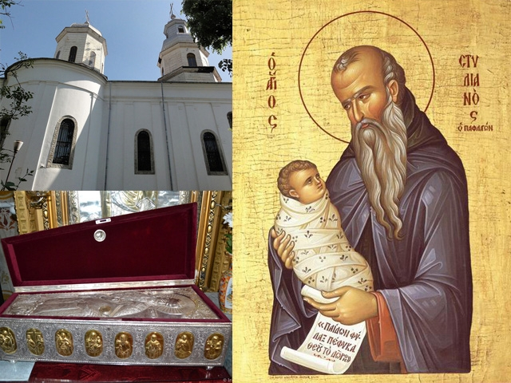
LET’S BE GOOD AT HEART LIKE THE SAINTS!
Saint Stylianos was born in a family of Christians from Paphlagonia (South of the Black Sea – in modern day Turkey), in the 6th century (600-700). His name, "Stylianos", means "the one on the pole", meaning a man who lives his life on a pole, in prayer.
Remaining orphan, he gave away his wealth to the poor and became a monk, leading a harsh life. That is why we call him "pious" today. He received a blessing from his spiritual Father and withdrew to a cave to pray in silence. That cave was lit up by his pure, bright soul, and an angel from heaven brought him food.
This is how Saint Stylianos spent his time in the cave: he fasted, prayed even during the night and loved silence. The other monks from Paphlagonia learned about the pious life of Saint Stylianos and were amazed by the beauty of his soul.
At the hour of his death, on November 26, the face of Saint Stylianos suddenly became radiant, and an angel appeared to receive his soul. His body remained for us as a holy relic, wonderworker: healer of body and soul illnesses, helper of families and protector of children.
Thus, whenever there was an infectious disease that killed children, Saint Stylianos was called to intercede through prayer, and the sick children were cured, and the mothers whose children had died gave birth to other healthy children. That is why Saint Stylianos is depicted in icons holding a baby in his arms.
Saint Stylianos is also a great protector of those who bear his name. A part of his holy relics were brought in 1736 to Bucharest to a church named after him.
By his life pleasing to God, he is a model for all of us.

WORKSHEET
In groups, fill in horizontally words expressing moral-religious behaviors:
L
O
V
E

Color St. Stylianos’ icon, then read the prayer:
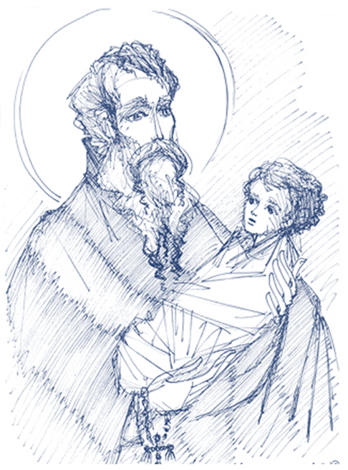
The mourning of the mothers in joy you have transformed, Saint Stylianos, giving them good children and healing the sick through your prayers, as one who has the Holy Spirit dwelling in you. For this, we, the faithful, knowing your wonderful and holy deeds, sing to you:
Rejoice, Saint Stylianos, Great Wonderworker!

Listen to the riddles read by the teacher and try to guess the answer:

1. Creator of Heaven,
Builder of the Earth,
Maker and
Savior of man.

2. Holding Jesus in her arms,
She greatly loves us;
She has mercy for us,
And helps us in need.

3. He is a soldier in the life’s battle,
He has the goodness weapon,
His prayer is his shield,
He is unknown to the world

