THE LITTLE CHRISTIAN IN THE CHURCH - GUIDE TO BEHAVIOR IN THE CHURCH
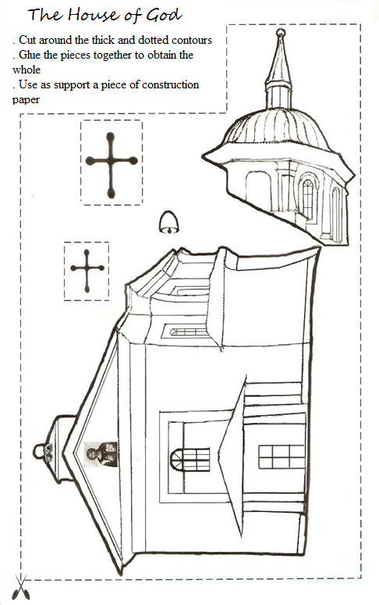
Fill in the blanks with the images below:

This morning, on my way to _________________________,
I stopped at the ___________________ on our street.
I entered, lighted a _____________ and I said
a _________________. Then I looked for a _______________
and I wrote a __________________. After I wrote it, I
gave it to the _________________, who blessed me
and told me to be study well and be good.
