ABOUT REPENTANCE
Saint Theodora of Sihla Saint Mary of Egypt
(August 7th) (April 1st)
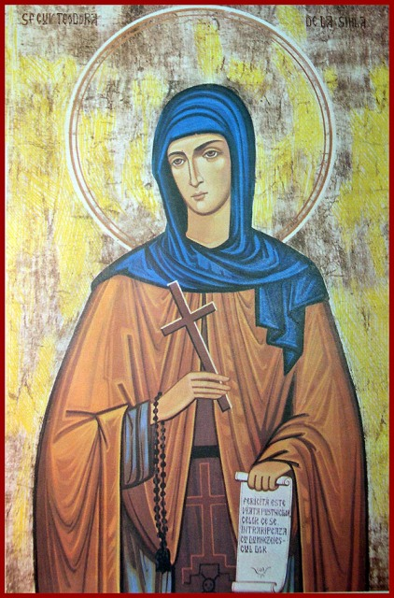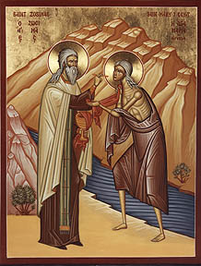
Repentance: is the change of mind that results in the change of actions.
Saint Theodora of Sihla can be considered a true spiritual guide for those who want to live with God. She was born in the village of Vânatori Neamț, around 1650. She was married for a short time, then both spouses decided to enter the monastic life. Eleutherios, the husband, chose the Skete of Poiana Mărului, and Theodora the Skete at Vărzărești-Râmnicu Sărat.
Saint Theodora, as a result of a divine revelation, left the Vrancea Mountains and withdrew to the Neamţ region. Here, she chose to live an ascetical life in the untouched forests around the Sihăstria and Sihla Sketes. She lived alone, unknown by people, for about thirty years. Her cell was in a cave in the Sihla Mountains. She was discovered through a miracle by two monks from the Sihastria Monastery. They followed a flock of birds that took bread from the monastery and went to the Sihla hermitage. Following the birds, they found the saint in prayer: her body was lifted up almost 2 meters off the ground. A divine light radiated around the saint.
Saint Theodora has prayed incessantly for the people who believe and love the Savior Jesus Christ, the Heavenly Father, the Blessed Virgin Mary, and the Holy Spirit. Holy Virgin Mary has not yet forgiven us for the betrayal of Sturza family, who gave the holy relics in exchange of some priests’ and hierarchs’ vestments, which would not have happened if the hierarchs of the Sihla Skete had not allowed Sturza to take the Holy Relics to their domain from Miclăușeni-Iași!
Saint Mary of Egypt:
The Fifth Sunday of the Great Lent is dedicated to Saint Mary of Egypt. He lived in the second half of the fourth century and the beginning of the fifth century. She died in the year 431, during the reign of the Emperor Theodosius the Younger.
As indicated by her name, Mary was born in Egypt. She had left her parents at the age of twelve to go to Alexandria, where she spent the next seventeen years living an immoral life. At the age of 29 she leaved Alexandria and went to Jerusalem. The pretext was given to her by the pilgrimage of some young people from Egypt and Libya who were sailing to Jerusalem to attend the Feast of the Exaltation of the Holy Cross.
When she arrived in Jerusalem, she wanted to enter the Church of the Holy Sepulcher, but could not pass the threshold. She felt an invisible force preventing her from entering. She tried several times to get in, but to no avail. This is the moment when she understood that her impure life made her unworthy to enter that Holy place. She prayed to the Mother of God to make her entrance into the church possible, with the promise that she will completely change her way of life. She succeeded in worshiping the Holy Cross and made the decision to live her life in the wilderness of the Jordan. Saint Mary of Egypt lived in the desert for 47 years, in fasting and prayer. A year before her death, the mystery of her life was revealed to Father Zosimas, who brought her Holy Communion, and after a while he returned to bury her, being helped in digging the grave by a lion.
- Learn the religious hymn: “Holy God, Holy Mighty …”
- Color the drawings
